ACTION MINUTES

COUNCIL MEETING

25 MAY 2023

CAPE WINELANDS DISTRICT MUNICIPALITY

MINUTES OF THE ORDINARY COUNCIL MEETING OF THE CAPE WINELANDS DISTRICT MUNICIPALITY HELD ON THURSDAY, 25 MAY 2023 AT 10:16 IN THE COUNCIL CHAMBER, CAPE WINELANDS DISTRICT MUNICIPALITY, TRAPPES STREET, WORCESTER

PRESENT (3/2/1/2)

COUNCILLORS

Ald. D.D. Joubert (Speaker)
Ald. (Dr.) H. von Schlicht (Executive Mayor)
Ald. M. Sampson (Deputy Executive Mayor)
Cllr. W.M. Blom (Virtual)
Cllr. M.N. Bushwana
Cllr. G.J. Carinus
Cllr. P. Daniels
Cllr. A.J. du Plessis
Ald. R. Farao
Cllr. G.J. Fredericks
Ald. S. Goedeman
Cllr. E. Groenewald
Cllr. V. Hani
Cllr. F. Jacobs
Cllr. D.B. Janse
Cllr. J.J.S. Januarie
Cllr. C.O. Klaaste
Cllr. S.E. Korabie
Cllr. J. Kriel
Cllr. J. Maliti
Cllr. C. Manuel
Cllr. X.L. Mdemka
Ald. C. Meyer
Cllr. T.R. Mpulanyana
Cllr. R.S. Nalumango
Cllr. D.W. Nel
Cllr. L. Ngwane
Cllr. A.J. Pedro
Cllr. W.C. Petersen
Cllr. N. Phatsoane
Cllr. A.M. Richards
Cllr. N.D. Sauerman
Cllr. J. Smit
Cllr. M. Smit
Cllr. J.H.P. Steyn
Cllr. D. Swart
Cllr. M. van Stade
Cllr. C.F. Wilskut
GUEST:

Mr. T. Lombard (SALGA Western Cape)

OFFICIALS

Mr. H.F. Prins (Municipal Manager)
Ms. F.A. du Raan-Groenewald
Mr. F. van Eck
Mr. P.A. Williams
Ms. K. Smit
Ms. S.S. Sanders
Mr. M.J. Lesch
Mr. C.J.M. Arangie
Ms. B.T. Daries
Ms. E.J. Otto
Ms. R.A. Leo
Ms. G.C.N. Julie
Mr. C. Swart
Ms. M.R. Matthyse
Ms. J. Swanepoel
Ms. N.J. Fortuin
Mr. D.A. Heath
Ms. I. Willemse

C.1 OPENING (3/2/1/2)
_______________________________________________________________

The Speaker welcomed all present.

Councillor C.O. Klaaste opened the meeting with prayer.

The Speaker, on behalf of Council, conveyed his condolences to Councillor M.H. Yabo whose father passed away, as well as a Councillor from Prince Albert Municipality, and requested all to stand for a moment of silence.

C.2 ELECTION OF ACTING SPEAKER, IF NECESSARY (3/2/1/2)
_______________________________________________________________

Not applicable.

C.3 DISCLOSURE OF ANY DIRECT OR INDIRECT INTERESTS BY COUNCILLORS AND/OR OFFICIALS (3/4/1 & 4/8/4)
_______________________________________________________________

None.

C.4 APPLICATION FOR LEAVE OF ABSENCE (3/2/1/2)
_______________________________________________________________

COUNCILLORS

Cllr. M.S. Liebenberg (subject to submission and approval of prescribed leave form)
Cllr. M.H. Yabo (subject to submission and approval of prescribed leave form)

C.5 STATEMENTS AND COMMUNICATIONS BY THE SPEAKER (Verbatim)
(3/2/1/3)
_______________________________________________________________

Councillor Birthdays: May 2023

I would like to congratulate the following Councillors who celebrated their birthdays in May 2023:

06 May : Cllr. M.S. Liebenberg
28 May : Cllr. J.J.S. Januarie

A special word of welcome to Mr. T. Lombard from SALGA Western Cape who will attend a meeting of SALGA’s Women’s Commission on conclusion of the Council meeting with all our female Councillors.

I wish to confirm that former Councillor Peter de Villiers has resigned as a Councillor since he was sworn in as a Member of the Provincial Legislator.

Councillor Blom was hospitalized on two occasions during this month; I can confirm that he is well now and is present online.

During the past month I observed that we work collectively as a unit, and together we embrace the values of the Cape Winelands District Municipality, despite our political alliances. It is an honour for mee to serve this Council as a Speaker.

C.6 STATEMENTS AND COMMUNICATIONS BY THE EXECUTIVE MAYOR (Verbatim) (3/2/1/3)
_______________________________________________________________

Thank you Speaker, allow me to share a few statements and highlights with Council.

- Presidential Imbizo

Speaker, it was an exciting month for Cape Winelands District Municipality. We were honoured to host the 6th Presidential Imbizo. This Presidential Imbizo took place on Friday, 19 May 2023 at the Dal Josaphat Athletics Stadium in Paarl. This gathering aimed to provide a platform for meaningful dialogue between our esteemed President, key stakeholders, and the general public.

I would like to express my sincere gratitude to the Office of the Speaker who played an integral part in mobilising the public for the Presidential Imbizo. The involvement of all staff members in the Cape Winelands District Municipality undoubtedly contributed to the success of the outreach and enhanced democratic participation. Thank you to all departments, your work does not go unnoticed.

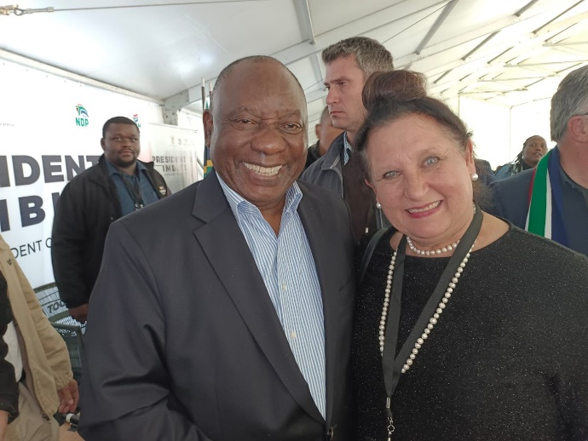

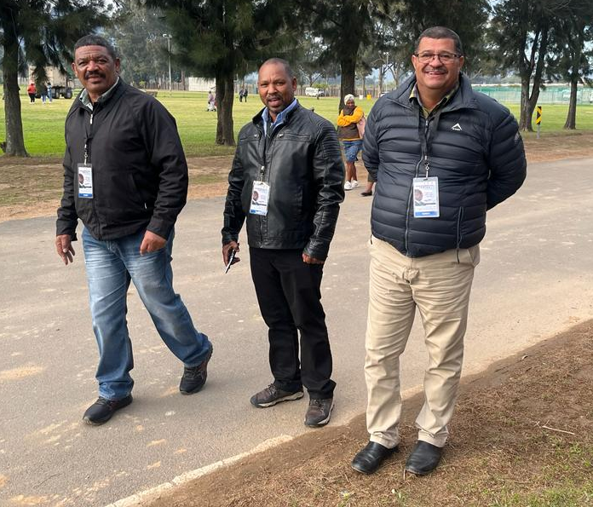 | 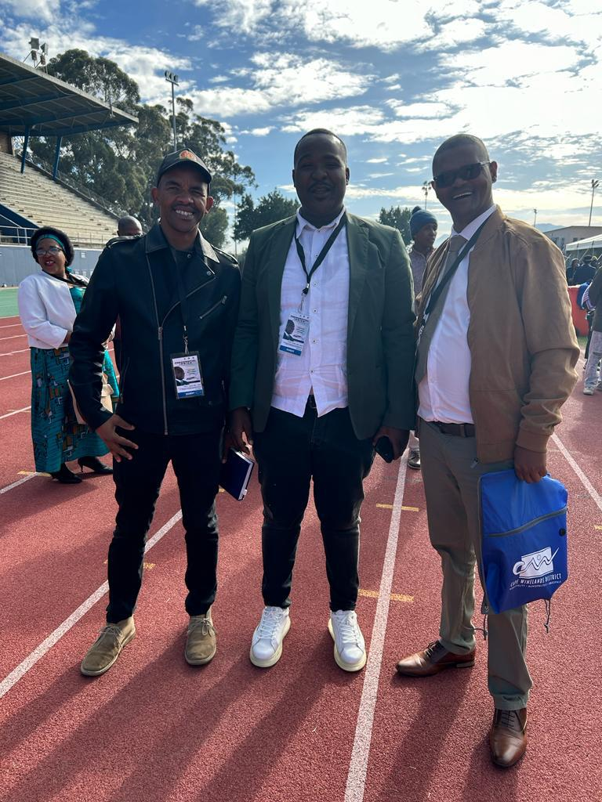

- Africa Day Celebrations

Speaker today, 25 May 2023 is Africa day and this year we commemorate the 60th anniversary of the establishment of the Organisation of African Unity. Let us come together and be reminded to honour the rich heritage, cultural diversity, and immense potential of the African continent. As we celebrate Africa’s achievements and progress, let us also renew our commitment to fostering unity, empowering the youth and the vulnerable, and working towards a future of peace, equality, and sustainable development for all Africans. May this day inspire us to embrace Africa's unique contributions to the world and strive for a brighter, inclusive, and prosperous future. Happy Africa Day!

- Dignity in Schools

Speaker, on 3 May 2023, CWDM attended the official handover of the newly completed ablution facilities at Errie Moller Primary School. This installation will not only add dignity to the lives of current learners but will impact many more to come.

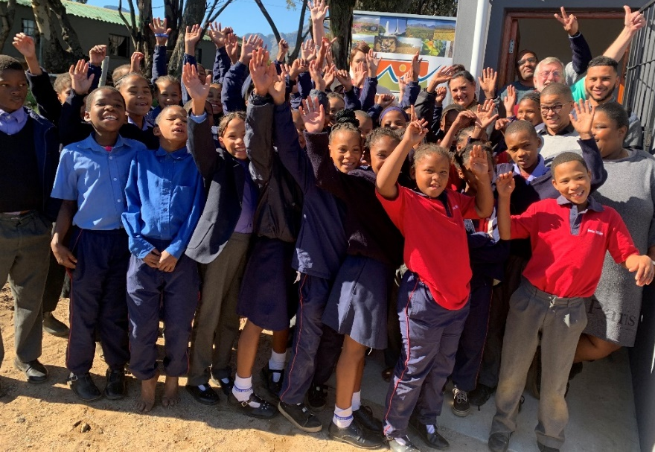
- International Firefighters Day

Speaker, on 4 May 2023, we commemorated International Firefighters Day. I want to express gratitude to all the staff involved who organised a memorable tribute to our brave men and women, who put their lives on the line to keep us safe. Thank you to the brave heroes for their unwavering commitment and dedication to the profession. As the Executive Mayor, I will continue to pledge my support to firefighters through our budget to ensure they have the resources they need to carry out their duties safely and effectively. To all firefighters, I salute you.

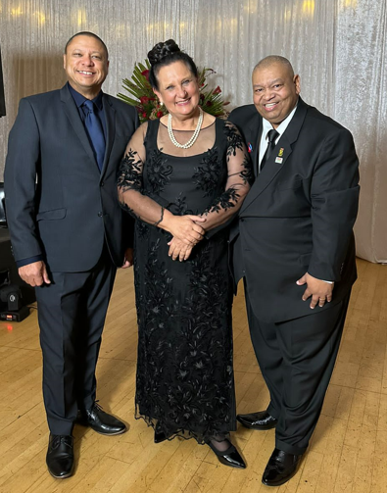

- Attracting Investment

In the months of April 2023 and May 2023, the Cape Winelands District Municipality attended several trade shows. The CWDM exhibition stands in Namibia and Durban attracted many visitors who are interested in doing business in the Cape Winelands. We are proud to play an integral part in growing our economy through tourism.

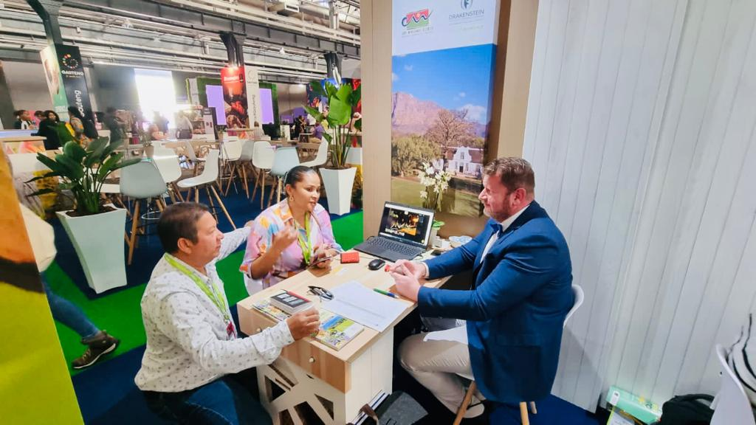

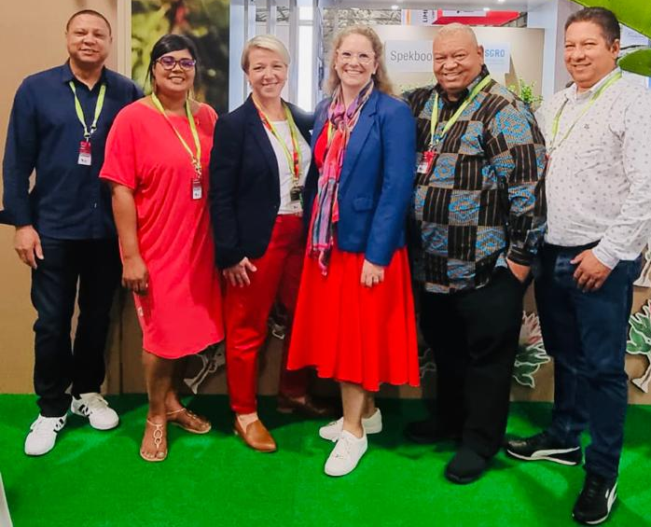

- Investing in our Youth

During the month of May 2023, CWDM visited several schools in our rural areas. We handed over stationary kits though our Technical Services Department and our Municipal Health Services had the opportunity to teach them of good personal health and hygiene. Our children in this district are the foundation of tomorrow, holding within them the power to shape a brighter, more compassionate, and innovative future for us all. We will remain committed through our projects to give youth resources to set them up for the future.

- A Word of Appreciation

As the Executive Mayor of Cape Winelands District Municipality, I want to say thank you to each and every staff member for your unwavering dedication, hard work, and commitment to excellence, which has been instrumental in the remarkable success and progress of our municipality thus far. Your collective efforts have transformed challenges into opportunities, and your passion for service has made a profound impact on the lives of our community members.

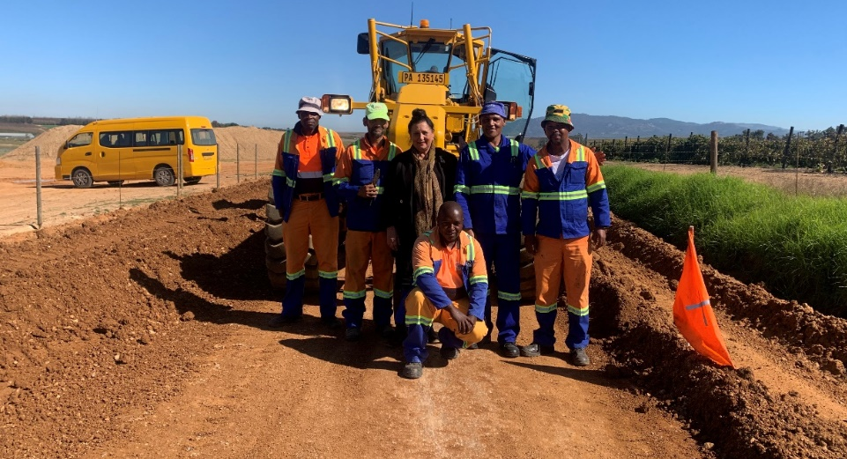

I thank you

C.7 CONSIDERATION OF NOTICES OF MOTION
_______________________________________________________________

None.

C.8 CONSIDERATION OF NOTICES OF QUESTIONS (3/2/1/5)
_______________________________________________________________

None.

C.9 CONSIDERATION OF MOTIONS OF EXIGENCY (3/2/1/4)
_______________________________________________________________

None.

C.10 MINUTES

C.10.1 CONFIRMATION OF THE MINUTES OF THE COUNCIL MEETING HELD ON TUESDAY, 25 APRIL 2023 (3/2/1/6)
_______________________________________________________________

COUNCIL MEETING: 25 MAY 2023: ITEM C.10.1

RESOLVED Unanimously:

That the minutes of the Council meeting held on Tuesday, 25 April 2023 be taken as read and duly confirmed.

C.10.2 REPORT BY THE MUNICIPAL MANAGER: ACTION MINUTES OF THE COUNCIL MEETING HELD ON TUESDAY, 25 APRIL 2023
______________________________________________________________

RESOLVED:

That cognisance be taken of the communication by the Municipal Manager that all matters pertaining to the action minutes of the Council meeting held on Tuesday, 25 April 2023 had been attended to.

C.11 INTERVIEWS WITH OR PRESENTATIONS BY DEPUTATIONS
_______________________________________________________________

C.11.1 PRESENTATION: EPWP – MR. C. SWART, DEPUTY DIRECTOR: PROJECT MANAGEMENT
_______________________________________________________________

COUNCIL MEETING: 25 MAY 2023: ITEM .11.1

RESOLVED:

*** That cognisance be taken of the presentation by the Deputy Director: Project Management, Mr. C. Swart, regarding EPWP, attached as Annexure “A” to the minutes.

C.12 URGENT MATTERS SUBMITTED BY THE MUNICIPAL MANAGER
_______________________________________________________________

None.

C.13 REPORT BY THE EXECUTIVE MAYOR: MAYORAL COMMITTEE MEETING HELD ON TUESDAY, 4 APRIL 2023 (3/2/2/1)
_______________________________________________________________

The following report outline the issues and decisions taken by the Mayoral Committee.

The relevant minutes of matters that served before the Executive Mayor and Mayoral Committee on the date indicated has been distributed to all Councillors -

1 MEETING HELD ON 4 APRIL 2023

MATTERS OF WHICH COGNISANCE WERE TAKEN:

MC.7.2 NOTIFICATION TO THE MAYORAL COMMITTEE: RESOLUTION BY THE EXECUTIVE MAYOR TOGETHER WITH THE MAYORAL COMMITTEE IN TERMS OF THE SYSTEM OF DELEGATIONS RECONFIRMED BY COUNCIL AT ITEM C.4.8 ON 2 DECEMBER 2021 (2/4/2)
______________________________________________________

RESOLVED:

That cognisance be taken of the item that served before the Mayoral Committee.

MC.7.3 NOTICE TO THE MAYORAL COMMITTEE: MINUTES OF A MEETING OF THE TRAINING COMMITTEE HELD ON TUESDAY, 29 NOVEMBER 2022 (3/2/5/1)
______________________________________________________

RESOLVED:

That cognisance be taken of the item that served before the Mayoral Committee.

MATTER OF WHICH RESOLUTION WAS TAKEN:

MC.8.2.1 MONTHLY PROGRESS REPORT ON MUNICIPAL MINIMUM COMPETENCY LEVELS: MARCH 2023 (4/12/5, 1/1/1 & 3/2/5/13)
______________________________________________________

RESOLVED:

That cognisance be taken of the decision taken by the Executive Mayor together with the Mayoral Committee.

C.14 MATTERS FOR NOTIFICATION
_______________________________________________________________

None.

C.15 MATTERS FOR CONSIDERATION
_______________________________________________________________

C.15.1 MONTHLY PROGRESS REPORT ON MUNICIPAL MINIMUM COMPETENCY LEVELS: APRIL 2023 (4/12/5, 1/1/1 & 3/2/5/13)
_______________________________________________________________

PURPOSE OF SUBMISSION

That Council consider to approve the monthly Municipal Minimum Competency Levels Progress Report for April 2023.

MUNICIPAL MINIMUM COMPETENCE COMPLIANCE LEVEL

Number of Municipal Officials that must comply with the MMCL 84
Number of Municipal Officials that comply with MMCL 76
Number of Municipal Officials that are currently in the process 8
to obtain the necessary qualifications

BACKGROUND

The Municipal Regulations on Minimum Competency Levels were first issued on 15 June 2007. This required municipalities and municipal entities to achieve full compliance by 1 January 2013. The Regulations required officials holding key positions and those that are responsible for financial management to comply with the prescribed minimum competencies relevant to their positions.

In April 2012, National Treasury issued MFMA Circular 60 aimed at assisting municipalities who were experiencing difficulties in complying with the legislation for officials already in the employ of the municipality. In accordance with the Circular, municipalities could apply to the National Treasury to consider a delay in enforcement of certain provisions of the regulations as a “Special Merit Case”.

On 14 March 2014, National Treasury issued a MFMA Exemption Notice to delay the enforceability of the Regulations. This Exemption Notice lapsed on 30 September 2015.

After consultation with key stakeholders and correspondence received from municipalities regarding the challenges faced in attracting and retaining key skills as a result of the prescribed minimum competency level requirements, a decision was taken to further exempt municipalities and municipal entities from the application of Regulations 15 and 18 of the Municipal Regulations on Minimum Competency Levels for a period of 18 months from 3 February 2017.
In order to effectively address the above situation, the Cape Winelands District Municipality embarked on a formal tender process to ensure the procurement of an accredited Municipal Finance Management Programme (MFMP) service provider. In March 2016 Kgolo Institute was appointed on a three-year contract as the preferred service provider for the CWDM’s Municipal Finance Management Programme. The Municipal Finance Management Programme were implemented via three intakes over a three-year contract period.

Intake 1 consisted of a combination of CWDM officials, those affected by the MFMA Regulations on Minimum Competency Levels, as well as those middle and junior management officials not affected by the MFMA Regulations on Minimum Competency Levels. Intake 1 concluded in January 2017.

Intake 2 commenced on 19 June 2017 and consisted of officials affected by the MFMA Regulations on Minimum Competency Levels, who have not participated in the previous Municipal Finance Management Programmes (MFMP). Intake 2 concluded in April 2018 and ensured that these officials were in full compliance with the prescribed competency levels on 02 August 2018, as stipulated in the MFMA Exemption Notice 40593.

Intake 3 commenced in July 2018 and consisted of outstanding middle and junior managers within the Cape Winelands District Municipality who are not affected by the Minimum Competency Levels. New appointees (Management Officials appointed after 3 February 2018 in terms of the MFMA Exemption Notice 40593) affected by the MMCL also formed part of Intake 3. Intake 3 concluded in April 2019.

Receipts of Statement of Results are administered by the LGSETA. Currently, the LGSETA has huge backlogs in terms of providing municipalities with these results. A number of affected CWDM officials have completed several Unit Standards and are currently awaiting their LGSETA certification. However, until such time that the CWDM receive these certificates to be issued by the LGSETA, it cannot be reflected in this report.

New Appointees - As from January 2019 (Not part of Intake 3) - All employees appointed after 1 January 2019 affected by the MFMA Exemption Notice 40593 embarked on the Municipal Finance Management Programme to ensure full compliance to the MMCL regulations. On 25 October 2019, the CWDM appointed Stellenbosch University (School of Public Leadership) as the new MFMP service provider. Affected officials commenced with the MFMP on 19 March 2020, however, the Covid-19 Lockdown negatively influenced the course schedules resulting in the postponement of the course, meaning that these affected learners completed their modules in September 2021.

COMMENT

*** On 3 February 2017, MFMA Exemption Notice 40593 was issued in terms of section 177(1) (b) of the MFMA relating to exemption from compliance with Regulations 15 and 18 of the Municipal Regulations on Minimum Competency levels (attached as Annexure “A”).

*** Attached, as Annexure B is the CWDM Bi-annual Municipal Regulation on Minimum Competency Levels Report submitted to National Treasury for Semester 2 (July 2022 – December 2022).

*** Attached, as Annexure “C” is the response received from National Treasury regarding feedback on the CWDM compliance status with regard to the CWDM Bi-annual Municipal Regulation on Minimum Competency Levels Report submitted to National Treasury for Semester 2 (July 2022 – December 2022).

*** Attached, as Annexure “D” is the National Treasury (NT) Status Report for the submission of CWDM Bi-annual Municipal Regulation on Minimum Competency Levels Report submitted to National Treasury for Semester 1 (January 2022 – June 2022), showing full compliance of the CWDM in terms of the below MFMA Exemption Notice and regulations.

Paragraphs 2.5 and 2.6 of the MFMA Exemption Notice stipulate as follows:

  - A municipality must –

- Submit a report to the National Treasury on the implementation of the conditions referred to in paragraph 2.1(a), in respect of the municipality and each of its entities in such format and on such dates as the National Treasury determines; and

(b) On a monthly basis, submit to the National Treasury and the relevant Provincial Treasury a report with details of –

- Employment contracts of officials appointed by virtue of this Notice;
(ii) Registration with accredited training providers; and
(iii) Progress made in attaining the minimum competency levels.

2.6 The report envisaged in paragraph 2.5(b) must be tabled at each municipal council meeting to enable the council to –

- Enforce the Regulations and this Notice; and

- Institute corrective action as may be required.

Chapter 2 of the Municipal Minimum Competency Level Regulations stipulates as follows:

(3) An accounting officer and officials involved in supply chain management must note that failure to comply with supply chain management responsibilities, functions and powers may constitute financial misconduct in terms of the Act.

In addition, Chapter 7 of the Municipal Minimum Competency Level Regulations stipulates as follows:

14. Reporting on and monitoring competency levels

(1) The municipal manager of a municipality and the chief executive officer of a municipal entity must monitor, and take any necessary steps to ensure, compliance with the prescribed minimum competency levels for financial officials and supply chain management officials within the timeframes set out in regulation 15.

(2) A municipality must report the consolidated information in respect of the municipality and each of its entities set out in sub-regulation (4) —

- to the National Treasury and to the relevant provincial treasury by 30 January and 30 July of each year, until 30 July 2015; and

- in its annual report, reflecting the information as at the end of the financial year to which the report relates.

(3) A municipal entity must report to its parent municipality by 20 January and 20 July of each year, and in its annual report, the information set out in sub regulation (4). The annual report of the municipal entity must reflect the information as at the end of the financial year to which the report relates.

(4) A report on the compliance with prescribed competency levels must be in the format set out in the Annexure hereto and include the following minimum information as at 30 June and 31 December of each year, as may be appropriate –

- the total number of financial officials employed;
- the total number of financial officials whose competency assessments have been completed;
- the total number of supply chain management officials employed;
- the total number of supply chain management officials whose competency assessments have been completed;

- the total number of financial officials and supply chain management officials that meet the prescribed competency levels; and
- the total number of financial officials and supply chain management officials whose performance agreements comply with regulation 16.

16. Attainment of competency levels within prescribed timeframes to be included in performance agreements

(1) If a financial official or supply chain management official is employed by a municipality or municipal entity subject to a performance agreement and that official does not meet the minimum competency levels, attainment of such competency levels within the timeframes set out in regulation 15 must be included as a performance target in that official’s performance agreement.

The CWDM, fully complies with all of the above regulatory requirements, by submitting the required bi-annual reports to National Treasury and the inclusion of Municipal Minimum Competency Levels Progress Report as part of the CWDM Annual Report.

In terms of compliance with the Municipal Regulations on Minimum Competency Levels of officials at the Cape Winelands District Municipality, they are grouped as follows:

Category | Number of officials who comply
Municipal Manager | 1
Chief Financial Officer | 1
Senior Managers | 2
Supply Chain Management Head | 1
Supply Chain Management Manager | 1
Financial Officials at Middle Management Level | 22
Officials involved in Implementation of Supply Chain Management Policy: Officials with Financial Delegations | 29
Officials involved in Implementation of Supply Chain Management Policy: Officials serving on Supply Chain Management Bid Committees | 18

OUTSTANDING: OFFICIALS CURRENTLY ON MFMP TRAINING
Job Title | Date of appointment | Category
Director: Roads | 01/04/2022 | Financial Officials at Middle Management Level - "middle management level" means a management level associated with persons in middle management positions for supervising staff and includes- (a) an official directly accountable to a manager in the senior management level; or (b) a person that occupied a position in a management level, outside the local government sphere.
Deputy Director: Roads | 01/11/2021 | Officials involved in Implementation of Supply Chain Management Policy: Officials with Financial Delegations
Deputy Director: Resealing & Maintenance | 01/07/2021 | Officials involved in Implementation of Supply Chain Management Policy: Officials with Financial Delegations
Deputy Director: Construction & Maintenance | 01/05/2020 | Officials involved in Implementation of Supply Chain Management Policy: Officials with Financial Delegations
Manager: Office of Executive Mayor | 10/02/2022 | Officials involved in Implementation of Supply Chain Management Policy: Officials with Financial Delegations
Occupational Health & Safety Officer | 01/04/2022 | Officials involved in Implementation of Supply Chain Management Policy: Officials with Financial Delegations
Chief Audit Executive | 01/05/2022 | Officials involved in Implementation of Supply Chain Management Policy: Officials with Financial Delegations
Deputy Director:  Legal Services | 01/12/2022 | Officials involved in Implementation of Supply Chain Management Policy: Officials with Financial Delegations

This graph illustrates the CWDM officials that were required to comply with the Municipal Minimum Competency Levels (as stipulated in the MFMA Exemption Notice 40593), by 02 August 2018. As evident on this graph, all affected sixty-seven (67) x officials complied by 02 August 2018.
This graph illustrates the newly appointed CWDM officials, appointed after 02 August 2018 (as stipulated in the MFMA Exemption Notice 40593), that should comply within the required 18-month period. Within the CWDM a total of fifteen (16) x officials (affected by the MMCL) were appointed after 02 August 2018, of which eight (8) x officials complied within the prescribed period. Currently, eight (8) x officials are registered on the Municipal Finance Management Programme (MFMP), for completion by October 2023.

Eight (8) new appointments were made respectively in 2020 and 2021, all falling under the category: Officials involved in the implementation of Supply Chain Management policy: officials with financial delegations. The latter together with three (3) new appointed Financial Interns, embarked on the Municipal Finance Management Programme with Next Step Academy (Pty) Ltd, who was appointed as the accredited service provider, for the implementation of the Municipal Finance Management Programme. This MFMP commenced on 19 April 2022 and will run until 30 October 2023.

IMPLICATIONS

PERSONNEL

Officials who were already in the employment of municipalities prior to 3 February 2017 were given until 2 August 2018 to complete all outstanding prescribed Unit Standards, in order to ensure full compliance with the Regulation.

To give effect to Exemption Notice 40593, all affected officials (already in the employ of the Cape Winelands District Municipality), who are involved in the implementation of the Supply Chain Management policy of the Municipality, must meet the prescribed financial management competency levels. In addition, it is required of them to sign a Memorandum of Agreement which, inter alia, stipulated the consequences to officials should they refuse to either complete their outstanding Unit Standards and/or refuse to participate in the Municipal Finance Management Programme (MFMP).

REMEDIAL ACTIONS TAKEN:

None – All participants are progressing as per training schedule.

Comment prepared by: Ms. G.C.N. Julie

FINANCIAL

Sufficient provision has been made in the 2022/2023 financial year for MMCL training of newly appointed employees.

Comment prepared by: Ms. F.A. du Raan-Groenewald

LEGAL

Section 119(1) of the Local Government: Municipal Finance Management Act, 2003 (Act No. 56 of 2003) (MFMA) stipulates that the accounting officer and all other officials of a municipality or a municipal entity involved in the implementation of the supply chain management policy of the municipality must meet the prescribed financial management competency levels, whilst section 119(2) stipulates that a municipality and a municipal entity must for the purposes of subsection 119(1) provide resources or opportunities for the training of officials referred to in that subsection to meet the prescribed competency levels.

In terms of regulation 13 of the Municipal Regulations on Minimum Competency Levels, 2007 the municipal manager of a municipality and the chief executive officer of a municipal entity must ensure that competencies of all financial officials and supply chain management officials are assessed in order to identify and address gaps in competency levels of those officials.

In terms of regulation 14(1) of the Municipal Regulations on Minimum Competency Levels, 2007 the municipal manager of a municipality and the chief executive officer of a municipal entity must monitor and take any necessary steps to ensure compliance with the prescribed minimum competency levels for Financial officials and supply chain management officials within the time frames set out in regulation 15.

Comment prepared by: Ms. S.S. Sanders

RECOMMENDATION BY MUNICIPAL MANAGER: That –

- The Executive Mayor and Mayoral Committee take cognisance of the monthly Municipal Minimum Competency Levels Progress Report for April 2023;

- The Executive Mayor together with the Mayoral Committee consider to recommend to Council to consider the monthly Municipal Minimum Competency Levels Progress Report for April 2023.

MAYORAL COMMITTEE: 2 MAY 2023: ITEM MC.8.2.1

RESOLVED: That –

(a) Cognisance be taken of the monthly Municipal Minimum Competency Levels Progress Report for April 2023, attached as Annexures “B”, “C”, “D” and “E” to the minutes;

(b) It be recommended to Council to consider the monthly Municipal Minimum Competency Levels Progress Report for April 2023.

RECOMMENDATION BY MAYORAL COMMITTEE:

RESOLVED :

That Council consider to approve the monthly Municipal Minimum Competency Levels Progress Report for April 2023.

COUNCIL MEETING: 25 MAY 2023: ITEM C.15.1

RESOLVED (38 Councillors) :

That the monthly Municipal Minimum Competency Levels Progress Report for April 2023, be approved.

ACTION | DUE DATE | COMMENT
Noted. | - | -

C.15.2 APPROVAL OF A DECREASE IN FUNDING RECEIVED FOR THE 2022/2023 FINANCIAL YEAR IN TERMS OF SECTION 28(2)(a) OF THE LOCAL GOVERNMENT: MUNICIPAL FINANCE MANAGEMENT ACT, 2003 (ACT NO. 56 OF 2003) (MFMA) AND REGULATION 23(3) OF THE MUNICIPAL BUDGET AND REPORTING REGULATIONS, 2008
(5/1/1/6 & 3/2/5/15)
_______________________________________________________________

PURPOSE OF SUBMISSION

That Council consider to approve an adjustments budget as contemplated in section 28(2)(a) of the Local Government: Municipal Finance Management Act, 2003 (Act No. 56 of 2003) (MFMA) and regulation 23(3) of the Municipal Budget and Reporting Regulations, 2008 to authorise a decrease in funding received for the 2022/2023 MTREF.

BACKGROUND

An adjustments budget, contemplated in section 28(2)(a) of the Local Government: Municipal Finance Management Act, 2003 (Act No. 56 of 2003) (MFMA), may appropriate additional revenues that have become available over and above those anticipated in the annual budget, but only to revise or accelerate spending programmes already budgeted for within a prescribed framework.

In addition, regulation 23(3) of the Municipal Budget and Reporting Regulations, 2008 (published in Government Gazette No. 32141 on 17 April 2009), determined the timeframes for the tabling of the said special adjustments budget as follows:

“If a national or provincial adjustments budget allocates or transfer additional revenues to a municipality, the mayor of the municipality must, at the next available council meeting, but within 60 days of the approval of the relevant national or provincial adjustments budget, table an adjustments budget referred to in section 28(2)(a) of the Act in the municipal council to appropriate these additional revenues.”

Grant funding of the Cape Winelands District Municipality (CWDM) was decreased in terms of Government Gazette No. 48327, attached as Annexure “D” and Addendum 2 to Memorandum of Agreement for the 2022/2023 Financial Year, attached as Annexure “E”.

- National Government

The Government Gazette No. 48327 indicated that the Rural Roads Asset Management Grant transfer will decrease from R2 877 000 to R72 000. This grant will however continue in the 2023/2024 financial year.

- Provincial Government

The Department of Transport and Public Works decreased their 2022/2023 budget for work on proclaimed roads with R4 600 000 from R121 700 000 to R117 100 000 in terms of Addendum 2 to Memorandum of Agreement for the 2022/2023 Financial Year.

Roads Expenditure in the Municipalities’ budget is governed by two Provincial Memorandum of Agreements since the provincial government’s financial yearend is 31 March and Municipalities’ financial yearend is 30 June. The decrease referred to above will not have any effect on the budget. The portion of the budget governed by the second Memorandum of Agreement was increased with the same amount.

COMMENTS

*** Due to the decrease of funding to the Municipality, operating budget items of the 2022/2023 had to be adjusted. See Annexures “A” (Revised Budget Document) and “F” (Revised Schedule B, supporting documents):

Expenditure

- Research and Advisory: Rural Roads Asset Management decrease from R2 877 000 to R72 000.

Revenue:

- Rural Roads Asset Management Services Grant decrease from R2 877 000 to R72 000.

*** Annexure “B” reflects a summary of the Total Operating Budget should the requested adjustments be approved and Annexure “C” reflects a summary of the Total Operating Budget before the requested adjustments.

IMPLICATIONS

PERSONNEL

None.

Comment prepared by: Ms. G.C.N. Julie

LEGAL

The legal implications have been addressed under “BACKGROUND” and “COMMENT” above.

Comment prepared by: Ms. S.S. Sanders

FINANCIAL

The financial implications have been addressed under “BACKGROUND” and “COMMENT” above.

Comment prepared by: Ms. F.A. du Raan-Groenewald

RECOMMENDATION BY MUNICIPAL MANAGER:

That Council consider to approve the decrease in revenue and expenditure for the 2022/2023 financial year as reflected in Annexures “A”, “B”, “C”, “D”, “E” and “F” in terms of section 28(2)(a) of the Local Government: Municipal Finance Management Act, 2003 (Act No. 56 of 2003) (MFMA) and regulation 23(3) of the Municipal Budget and Reporting Regulations, 2008.

COUNCIL MEETING: 25 MAY 2023: ITEM C.15.2

Councillor T.R. Mpulanyana requested a caucus which was granted.

Council adjourned at 11:07 and resumed its business at 11:15.

Councillor T.R. Mpulanyana reported on the outcome of the caucus and confirmed that the explanation provided by the Executive Director: Technical Services for the decrease in revenue and expenditure for the 2022/2023 financial year as reflected in Annexures “A”, “B”, “C”, “D”, “E” and “F” in terms of section 28(2)(a) of the Local Government: Municipal Finance Management Act, 2003 (Act No. 56 of 2003) (MFMA) and regulation 23(3) of the Municipal Budget and Reporting Regulations, 2008 is accepted.

Councillor E. Groenewald, seconded by Councillor F. Jacobs, proposed that the decrease in revenue and expenditure for the 2022/2023 financial year as reflected in Annexures “A”, “B”, “C”, “D”, “E” and “F” in terms of section 28(2)(a) of the Local Government: Municipal Finance Management Act, 2003 (Act No. 56 of 2003) (MFMA) and regulation 23(3) of the Municipal Budget and Reporting Regulations, 2008, be approved.

The matter was put to the vote and twenty-six (26) Councillors voted in favour of the proposal.

The following nine (9) Councillors abstained from voting:

Cllr. M.N. Bushwana
Cllr. V. Hani
Cllr. J.J.S. Januarie
Cllr. C.O. Klaaste
Cllr. J. Maliti
Cllr. T.R. Mpulanyana
Cllr. R.S. Nalumango
Cllr. N. Phatsoane
Cllr. A.M. Richards

RESOLVED :

That the decrease in revenue and expenditure for the 2022/2023 financial year as reflected in Annexures “A”, “B”, “C”, “D”, “E” and “F” in terms of section 28(2)(a) of the Local Government: Municipal Finance Management Act, 2003 (Act No. 56 of 2003) (MFMA) and regulation 23(3) of the Municipal Budget and Reporting Regulations, 2008, be approved.

ACTION | DUE DATE | COMMENTS
Ms FA du Raan-Groenewald (BTO) to attend to the matter.  Ms FA du Raan-Groenewald (Admin Support) to attend to the publication of the Annual Budget | 30 June 2023  26 May 2023 | Official notices will be published in newspapers as from 26 May 2023.

(The meeting adjourned at 11:19 and resumed its business at 11:38)

C.15.3 DRAFT 2023/2024, 2024/2025 AND 2025/2026 MEDIUM TERM REVENUE AND EXPENDITURE FRAMEWORK (MTREF) FOR THE CAPE WINELANDS DISTRICT MUNICIPALITY (5/1/1/10)
_______________________________________________________________

PURPOSE OF SUBMISSION

That Council consider to adopt the draft 2023/2024, 2024/2025 and 2025/2026 Medium Term Revenue and Expenditure Framework (MTREF) for the Cape Winelands District Municipality.

BACKGROUND

In terms of section 16 of the Local Government: Municipal Finance Management Act, 2003 (Act No. 56 of 2003) (MFMA) a council of a municipality must for each financial year approve an annual budget for the municipality before the start of the financial year.

In order for a municipality to comply with section 16(1) of the said Act, the mayor must table the annual budget at a council meeting at least 90 days before the start of the budget year.

Section 15 of the MFMA prescribes that a municipality may incur expenditure only:

15 (a) In terms of an approved budget; and

(b) Within the limits of the amounts appropriated for the different votes in an approved budget.

The contents of the annual budget must consist of the following documents as prescribed in terms of section 17 of the MFMA:

1. Realistically anticipated income and expenditure per vote for the budget year and the two financial years following the budget year;

2. Budget related policies of the Council (Tariff, Rates & Credit Control Policies);

3. Details of Council’s investments for the budget year;

4. Details of all proposed service delivery agreements, including material amendments to existing service delivery agreements;

5. Particulars of any proposed allocations or grants by the municipality in terms of sections 67 and 17(3)(j) of the MFMA;

6. The proposed cost to the municipality for the budget year of the salary, allowances and benefits of political office bearers and senior managers;

7. Capital expenditure and projects envisioned within the budget year.

COMMENT

*** Attached as Annexures “A” to “R” is a copy of the draft 2023/2024, 2024/2025 and 2025/2026 Medium Term Revenue and Expenditure Framework (MTREF) for the Cape Winelands District Municipality as well as related documents as prescribed by the Local Government: Municipal Finance Management Act, 2003 (Act No. 56 of 2003) (MFMA).

The IDP/Budget process for the 2023/2024 financial year was a consultative process – including the Budget Steering Committee, Executive Directors, Senior Managers, Councillors and other stakeholders.

The MTREF (2023 – 2026) has been compiled in accordance with the budget growth guidelines determined by National Treasury. Personnel expenditure (Salaries, Wages and Allowances) increased by 5.4% for 2023/2024,2024/2025 and 2025/2026. The Budget Steering Committee, established in terms of the Budget and Reporting Regulations, 2008, comprehensively scrutinised the proposed MTREF.

Due to strict budgetary control, management succeeded to compile a balanced budget.

DECLARATION BY MANAGEMENT

Management declare that they followed all guidelines prescribed by the relevant legislation during the budget process.

RECOMMENDATION BY MUNICIPAL MANAGER:

- That the Executive Mayor together with the Mayoral Committee consider to recommend to Council to adopt the draft 2023/2024, 2024/2025 and 2025/2026 Medium Term Revenue and Expenditure Framework (MTREF) for the Cape Winelands District Municipality as outlined in the attached Annexures for public participation for inspection, public representations, inputs and comment:

- The draft Medium Term Revenue and Expenditure Framework for the 2023/2024, 2024/2025 and 2025/2026 financial years as set out in Annexure “A”;

(ii) Adjustments to the budget related policies submitted as Annexure “B”;

(iii) Details of Council’s investments as set out in Annexure “C”;

(iv) Details of all proposed service delivery agreements, including material amendments to existing service delivery agreements as set out in Annexure “D”;

(v) Adjustments to the current Integrated Development Plan (IDP) as set out in Annexure “E” on the flash drives distributed to Councillors receiving a hard copy of the Mayoral Committee agenda;

(vi) Details of employment costs – salaries, allowances and benefits – of all political office-bearers, councillors and senior managers of the Cape Winelands District Municipality as set out in Annexure “F”;

(vii) Capital expenditure within the budget year as set out in Annexure “G”;

(viii) Projects to be undertaken within the budget year as set out in Annexure “H”;

(ix) Particulars of all proposed allocations and grants by the District Municipality in terms of section 67 of the MFMA, as set out in Annexure “I”;

(x) Proposed Tariffs for the 2023/2024 financial year as set out in Annexure “J”;

- Service Delivery Standard as set out in Annexure “K”;

- Measurable performance objectives for revenue from each source and for each vote in the budget, taking into account the District Municipality’s Integrated Development Plan (IDP) as part of Annexure “L”;

- Demand Plan as set out in Annexure “M”;

- That cognisance be taken of –

- MFMA Circular No. 122: Municipal Budget Circular for the 2023/2024 MTREF – 09 December 2022, attached as Annexure “N”;

- The Cape Winelands District Municipality’s:

- Air Quality Management Plan, attached as Annexure “O”;

- Draft Spatial Development Framework (2021-2025), attached as Annexure “P”;

(cc) Integrated Waste Management Plan, attached as Annexure “Q”;

- Corporate Disaster Management Planning Framework, attached as Annexure “R”;

(c) Annexure “E” and all the annexures referred to in subsection (b) of the recommendation by the Municipal Manager, will be distributed via flash drive to the Councillors receiving a hard copy of the Mayoral Committee agenda.

MAYORAL COMMITTEE: 7 MARCH 2023: ITEM MC.8.8.2

RESOLVED: That –

  - It be recommended to Council to adopt the draft 2023/2024, 2024/2025 and 2025/2026 Medium Term Revenue and Expenditure Framework (MTREF), as amended, for the Cape Winelands District Municipality as outlined in the attached Annexures for public participation for inspection, public representations, inputs and comment:

- The draft Medium Term Revenue and Expenditure Framework for the 2023/2024, 2024/2025 and 2025/2026 financial years as set out in Annexure “A”;

(ii) Adjustments to the budget related policies submitted as Annexure “B”;

(iii) Details of Council’s investments as set out in Annexure “C”;

(iv) Details of all proposed service delivery agreements, including material amendments to existing service delivery agreements as set out in Annexure “D”;

(v) Adjustments to the current Integrated Development Plan (IDP) as set out in Annexure “E” on the flash drives distributed to Councillors receiving a hard copy of the Mayoral Committee agenda;

(vi) Details of employment costs – salaries, allowances and benefits – of all political office-bearers, councillors and senior managers of the Cape Winelands District Municipality as set out in Annexure “F”;

(vii) Capital expenditure within the budget year as set out in Annexure “G”;

(viii) Projects to be undertaken within the budget year as set out in Annexure “H”;

(ix) Particulars of all proposed allocations and grants by the District Municipality in terms of section 67 of the MFMA, as set out in Annexure “I”;

(x) Proposed Tariffs for the 2023/2024 financial year as set out in Annexure “J”;

(xi) Service Delivery Standard as set out in Annexure “K”;

(xii) Measurable performance objectives for revenue from each source and for each vote in the budget, taking into account the District Municipality’s Integrated Development Plan (IDP) as part of Annexure “L”;

(xiii) Demand Plan as set out in Annexure “M”;

  - That cognisance be taken of –

- MFMA Circular No. 122: Municipal Budget Circular for the 2023/2024 MTREF – 09 December 2022, attached as Annexure “N”;

(ii) MFMA Circular No. 123: Municipal Budget Circular for the 2023/2024 MTREF – 03 March 2023, attached as Annexure “A” to the minutes;

- The Cape Winelands District Municipality’s:

- Air Quality Management Plan, attached as Annexure “O”;

- Draft Spatial Development Framework (2021-2025), attached as Annexure “P”;

- Integrated Waste Management Plan, attached as Annexure “Q”;

- Corporate Disaster Management Planning Framework, attached as Annexure “R”;

(c) Annexure “E” and all the annexures referred to in subsection (b) of the recommendation by the municipal manager, will be distributed via flash drive to the Councillors receiving a hard copy of the Mayoral Committee agenda.

RECOMMENDATION BY THE MAYORAL COMMITTEE:

  - That it be recommended to Council to adopt the draft 2023/2024, 2024/2025 and 2025/2026 Medium Term Revenue and Expenditure Framework (MTREF), as amended, for the Cape Winelands District Municipality as outlined in the attached Annexures for public participation for inspection, public representations, inputs and comment:

- The draft Medium Term Revenue and Expenditure Framework for the 2023/2024, 2024/2025 and 2025/2026 financial years as set out in Annexure “A”;

(ii) Adjustments to the budget related policies submitted as Annexure “B”;

(iii) Details of Council’s investments as set out in Annexure “C”;

(iv) Details of all proposed service delivery agreements, including material amendments to existing service delivery agreements as set out in Annexure “D”;

(v) Adjustments to the current Integrated Development Plan (IDP) as set out in Annexure “E” on the flash drives distributed to Councillors receiving a hard copy of the Mayoral Committee agenda;

(vi) Details of employment costs – salaries, allowances and benefits – of all political office-bearers, councillors and senior managers of the Cape Winelands District Municipality as set out in Annexure “F”;

(vii) Capital expenditure within the budget year as set out in Annexure “G”;

(viii) Projects to be undertaken within the budget year as set out in Annexure “H”;

(ix) Particulars of all proposed allocations and grants by the District Municipality in terms of section 67 of the MFMA, as set out in Annexure “I”;

(x) Proposed Tariffs for the 2023/2024 financial year as set out in Annexure “J”;

(xi) Service Delivery Standard as set out in Annexure “K”;

(xii) Measurable performance objectives for revenue from each source and for each vote in the budget, taking into account the District Municipality’s Integrated Development Plan (IDP) as part of Annexure “L”;

(xiii) Demand Plan as set out in Annexure “M”;

  - That cognisance be taken of –

- MFMA Budget Circulars for the 2023/2024 MTREF No. 122 dated 09 December 2022 and No. 123 dated 03 March 2023 , attached as Annexure “N”;

- The Cape Winelands District Municipality’s:

- Air Quality Management Plan, attached as Annexure “O”;

- Draft Spatial Development Framework (2021-2025), attached as Annexure “P”;

- Integrated Waste Management Plan, attached as Annexure “Q”;

- Corporate Disaster Management Planning Framework, attached as Annexure “R”;

(c) Annexure “E” and all the annexures referred to in subsection (b) of the recommendation by the municipal manager, will be distributed via flash drive to Councillors receiving a hard copy of the Council agenda.

COUNCIL MEETING: 23 MARCH 2023: ITEM C.15.4

RESOLVED: (34 Councillors) That –

- The draft 2023/2024, 2024/2025 and 2025/2026 Medium Term Revenue and Expenditure Framework (MTREF), as amended, for the Cape Winelands District Municipality as outlined in the attached Annexures for public participation for inspection, public representations, inputs and comment, be approved:

- The draft Medium Term Revenue and Expenditure Framework for the 2023/2024, 2024/2025 and 2025/2026 financial years as set out in Annexure “A”;

(ii) Adjustments to the budget related policies submitted as Annexure “B”;

(iii) Details of Council’s investments as set out in Annexure “C”;

(iv) Details of all proposed service delivery agreements, including material amendments to existing service delivery agreements as set out in Annexure “D”;

(v) Adjustments to the current Integrated Development Plan (IDP) as set out in Annexure “E” on the flash drives distributed to Councillors receiving a hard copy of the Mayoral Committee agenda;

(vi) Details of employment costs – salaries, allowances and benefits – of all political office-bearers, councillors and senior managers of the Cape Winelands District Municipality as set out in Annexure “F”;

(vii) Capital expenditure within the budget year as set out in Annexure “G”;

(viii) Projects to be undertaken within the budget year as set out in Annexure “H”;

(ix) Particulars of all proposed allocations and grants by the District Municipality in terms of section 67 of the MFMA, as set out in Annexure “I”;

(x) Proposed Tariffs for the 2023/2024 financial year as set out in Annexure “J”;

(xi) Service Delivery Standard as set out in Annexure “K”;

(xii) Measurable performance objectives for revenue from each source and for each vote in the budget, taking into account the District Municipality’s Integrated Development Plan (IDP) as part of Annexure “L”;

(xiii) Demand Plan as set out in Annexure “M”;

- Cognisance be taken of –

- MFMA Budget Circulars for the 2023/2024 MTREF No. 122 dated 09 December 2022 and No. 123 dated 03 March 2023, attached as Annexure “N”;

- The Cape Winelands District Municipality’s:

- Air Quality Management Plan, attached as Annexure “O”;

- Draft Spatial Development Framework (2021-2025), attached as Annexure “P”;

- Integrated Waste Management Plan, attached as Annexure “Q”;

- Corporate Disaster Management Planning Framework, attached as Annexure “R”;

- Annexure “E” and all the annexures referred to in subsection (b) of the recommendation by the municipal manager, will be distributed via flash drive to Councillors receiving a hard copy of the Council agenda.

ADDITIONAL COMMENTS

No formal written feedback was received to date on the MTREF tabled on 23 March 2023, however the following adjustments have been made to the tabled MTREF:

- Addition of Hazmat Equipment to the Capital Budget to the value of R500 000 funded by the Capacity Building Grant which was omitted from the Budget;

- Addition of Fire Services Capacity Building Grant to the value of R500 000, to the Operational Budget (Non-Exchange Revenue);

(c) Top Achievers awards was increased with R1 600 000;

(d) Performance Management Software on the Capital Budget was decreased from R2 500 000 to R200 000;

(e) The Wesgro Trade Missions item was increased from R100 000 to R350 000.

RECOMMENDATION BY MUNICIPAL MANAGER:

That the Executive Mayor together with the Mayoral Committee consider to recommend to Council to approve the following:

- The draft 2023/2024, 2024/2025 and 2025/2026 Medium Term Revenue and Expenditure Framework (MTREF), as amended, for the Cape Winelands District Municipality as outlined in the attached Annexures for public participation for inspection, public representations, inputs and comment, be adopted:

(i) The draft Medium Term Revenue and Expenditure Framework for the 2023/2024, 2024/2025 and 2025/2026 financial years as set out in Annexure “A”;

(ii) Adjustments to the budget related policies submitted as Annexure “B” on the flash drive;

(iii) Details of Council’s investments as set out in Annexure “C”;

(iv) Details of all proposed service delivery agreements, including material amendments to existing service delivery agreements as set out in Annexure “D”;

(v) Adjustments to the current Integrated Development Plan (IDP) as set out in Annexure “E” on the flash drive;

(vi) Details of employment costs – salaries, allowances and benefits – of all political office-bearers, councillors and senior managers of the Cape Winelands District Municipality as set out in Annexure “F”;

(vii) Capital expenditure within the budget year as set out in Annexure “G”;

(viii) Projects to be undertaken within the budget year as set out in Annexure “H”;

(ix) Particulars of all proposed allocations and grants by the District Municipality in terms of section 67 of the MFMA, as set out in Annexure “I”;

(x) Proposed Tariffs for the 2023/2024 financial year as set out in Annexure “J”;

(xi) Service Delivery Standard as set out in Annexure “K”;

(xii) Measurable performance objectives for revenue from each source and for each vote in the budget, taking into account the District Municipality’s Integrated Development Plan (IDP) as part of Annexure “L”;

(xiii) Demand Plan as set out in Annexure “M”;

- Cognisance be taken of the following documents included on the flash drive –

(i) MFMA Budget Circulars for the 2023/2024 MTREF No. 122 dated 09 December 2022 and No. 123 dated 03 March 2023, attached as Annexure “N”;

(ii) The Cape Winelands District Municipality’s:

- Air Quality Management Plan, attached as Annexure “O”;

- Draft Spatial Development Framework (2021-2025), attached as Annexure “P”;

- Integrated Waste Management Plan, attached as Annexure “Q”;

- Corporate Disaster Management Planning Framework, attached as Annexure “R”.

MAYORAL COMMITTEE: 2 MAY 2023: ITEM MC.8.2.2

RESOLVED:

That it be recommended to Council to approve the following:

- The draft 2023/2024, 2024/2025 and 2025/2026 Medium Term Revenue and Expenditure Framework (MTREF), as amended, for the Cape Winelands District Municipality as outlined in the attached Annexures for public participation for inspection, public representations, inputs and comment, be adopted:

(i) The draft Medium Term Revenue and Expenditure Framework for the 2023/2024, 2024/2025 and 2025/2026 financial years as set out in Annexure “A”;

(ii) Adjustments to the budget related policies submitted as Annexure “B” on the flash drive;

(iii) Details of Council’s investments as set out in Annexure “C”;

(iv) Details of all proposed service delivery agreements, including material amendments to existing service delivery agreements as set out in Annexure “D”;

(v) Adjustments to the current Integrated Development Plan (IDP) as set out in Annexure “E” on the flash drive;

(vi) Details of employment costs – salaries, allowances and benefits – of all political office-bearers, councillors and senior managers of the Cape Winelands District Municipality as set out in Annexure “F”;

(vii) Capital expenditure within the budget year as set out in Annexure “G”;

(viii) Projects to be undertaken within the budget year as set out in Annexure “H”;

(ix) Particulars of all proposed allocations and grants by the District Municipality in terms of section 67 of the MFMA, as set out in Annexure “I”;

(x) Proposed Tariffs for the 2023/2024 financial year as set out in Annexure “J”;

(xi) Service Delivery Standard as set out in Annexure “K”;

(xii) Measurable performance objectives for revenue from each source and for each vote in the budget, taking into account the District Municipality’s Integrated Development Plan (IDP) as part of Annexure “L”;

(xiii) Demand Plan as set out in Annexure “M”;

- Cognisance be taken of the following documents included on the flash drive –

(i) MFMA Budget Circulars for the 2023/2024 MTREF No. 122 dated 09 December 2022 and No. 123 dated 03 March 2023, attached as Annexure “N”;

(ii) The Cape Winelands District Municipality’s:

- Air Quality Management Plan, attached as Annexure “O”;

- Draft Spatial Development Framework (2021-2025), attached as Annexure “P”;

- Integrated Waste Management Plan, attached as Annexure “Q”;

- Corporate Disaster Management Planning Framework, attached as Annexure “R”.

RECOMMENDATION BY MAYORAL COMMITTEE:

That Council consider to approve the following:

- The draft 2023/2024, 2024/2025 and 2025/2026 Medium Term Revenue and Expenditure Framework (MTREF), as amended, for the Cape Winelands District Municipality as outlined in the attached Annexures for public participation for inspection, public representations, inputs and comment, be adopted:

(i) The draft Medium Term Revenue and Expenditure Framework for the 2023/2024, 2024/2025 and 2025/2026 financial years as set out in Annexure “A”;

(ii) Adjustments to the budget related policies submitted as Annexure “B” on the flash drive;

(iii) Details of Council’s investments as set out in Annexure “C”;

(iv) Details of all proposed service delivery agreements, including material amendments to existing service delivery agreements as set out in Annexure “D”;

(v) Adjustments to the current Integrated Development Plan (IDP) as set out in Annexure “E” on the flash drive;

(vi) Details of employment costs – salaries, allowances and benefits – of all political office-bearers, councillors and senior managers of the Cape Winelands District Municipality as set out in Annexure “F”;

(vii) Capital expenditure within the budget year as set out in Annexure “G”;

(viii) Projects to be undertaken within the budget year as set out in Annexure “H”;

(ix) Particulars of all proposed allocations and grants by the District Municipality in terms of section 67 of the MFMA, as set out in Annexure “I”;

(x) Proposed Tariffs for the 2023/2024 financial year as set out in Annexure “J”;

(xi) Service Delivery Standard as set out in Annexure “K”;

(xii) Measurable performance objectives for revenue from each source and for each vote in the budget, taking into account the District Municipality’s Integrated Development Plan (IDP) as part of Annexure “L”;

(xiii) Demand Plan as set out in Annexure “M”;

- Cognisance be taken of the following documents included on the flash drive –

(i) MFMA Budget Circulars for the 2023/2024 MTREF No. 122 dated 09 December 2022 and No. 123 dated 03 March 2023, attached as Annexure “N”;

(ii) The Cape Winelands District Municipality’s:

- Air Quality Management Plan, attached as Annexure “O”;

- Draft Spatial Development Framework (2021-2025), attached as Annexure “P”;

- Integrated Waste Management Plan, attached as Annexure “Q”;

- Corporate Disaster Management Planning Framework, attached as Annexure “R”.

- Report on the Strategic Integrated Municipal Engagement 2023 attached as Annexure “S”.

COUNCIL MEETING: 25 MAY 2023: ITEM C.15.3

*** The Executive Mayor presented her Budget Speech on the draft 2023/2024, 2024/2025 and 2025/2026 Medium Term Revenue and Expenditure Framework (MTREF) for the Cape Winelands District Municipality to Council, a copy of which is attached as Annexure “B“ to the minutes.

The Executive Mayor, Alderman (Dr.) H. von Schlicht tabled the draft 2023/2024, 2024/2025 and 2025/2026 Medium Term Revenue and Expenditure Framework (MTREF) for the Cape Winelands District Municipality.

Councillor A.J. Pedro requested a caucus with the Speaker and Whips of political party’s represented in Council which was granted.

The meeting adjourned at 12:15 and resumed its business at 12:26.

Councillor A.J. Pedro reported back on the outcome of the caucus and confirmed that Councillor M. van Stade neglected to declare his indirect interest pertaining to projects contained in the budget.

Councillor M. van Stade declared his indirect interest pertaining to projects contained in Item C.15.3 of the agenda in terms of Item 6(1) of the Code of Conduct for Councillors as contained in Schedule 7 of the Local Government: Municipal Structures Act, 1998 (Act No. 117 of 1998), as amended, with specific reference to his wife’s non-profitable organisation being a possible recipient of grant funding and excused himself from the meeting.

Councillors T.R. Mpulanyana, D.W. Nel, A.J. Pedro and W.C. Petersen congratulated the Executive Mayor on the Budget Speech and indicated their support for the draft 2023/2024, 2024/2025 and 2025/2026 Medium Term Revenue and Expenditure Framework (MTREF) for the Cape Winelands District Municipality.

*** Attached as Annexure “C” to the minutes is a copy of questions pertaining to Annexure “S” of the agenda item submitted by Councillor D.W. Nel which was comprehensively addressed during the meeting.

The Executive Mayor, seconded by Councillor T.R. Mpulanyana, proposed that the draft 2023/2024, 2024/2025 and 2025/2026 Medium Term Revenue and Expenditure Framework (MTREF) for the Cape Winelands District Municipality be approved.

The proposal by the Executive Mayor was put to the vote and 37 Councillors voted in favour of the proposal.

RESOLVED (37 Councillors) (Unanimously) : That –

- The draft 2023/2024, 2024/2025 and 2025/2026 Medium Term Revenue and Expenditure Framework (MTREF), as amended, for the Cape Winelands District Municipality as outlined in the attached Annexures for public participation for inspection, public representations, inputs and comment, be approved:

(i) The draft Medium Term Revenue and Expenditure Framework for the 2023/2024, 2024/2025 and 2025/2026 financial years as set out in Annexure “A”;

(ii) Adjustments to the budget related policies submitted as Annexure “B” on the flash drive;

(iii) Details of Council’s investments as set out in Annexure “C”;

(iv) Details of all proposed service delivery agreements, including material amendments to existing service delivery agreements as set out in Annexure “D”;

(v) Adjustments to the current Integrated Development Plan (IDP) as set out in Annexure “E” on the flash drive;

(vi) Details of employment costs – salaries, allowances and benefits – of all political office-bearers, councillors and senior managers of the Cape Winelands District Municipality as set out in Annexure “F”;

(vii) Capital expenditure within the budget year as set out in Annexure “G”;

(viii) Projects to be undertaken within the budget year as set out in Annexure “H”;

(ix) Particulars of all proposed allocations and grants by the District Municipality in terms of section 67 of the MFMA, as set out in Annexure “I”;

(x) Proposed Tariffs for the 2023/2024 financial year as set out in Annexure “J”;

(xi) Service Delivery Standard as set out in Annexure “K”;

(xii) Measurable performance objectives for revenue from each source and for each vote in the budget, taking into account the District Municipality’s Integrated Development Plan (IDP) as part of Annexure “L”;

(xiii) Demand Plan as set out in Annexure “M”;

- Cognisance be taken of the following documents included on the flash drive –

(i) MFMA Budget Circulars for the 2023/2024 MTREF No. 122 dated 09 December 2022 and No. 123 dated 03 March 2023, attached as Annexure “N”;

(ii) The Cape Winelands District Municipality’s:

- Air Quality Management Plan, attached as Annexure “O”;

- Draft Spatial Development Framework (2021-2025), attached as Annexure “P”;

- Integrated Waste Management Plan, attached as Annexure “Q”;

- Corporate Disaster Management Planning Framework, attached as Annexure “R”.

- Report on the Strategic Integrated Municipal Engagement 2023 attached as Annexure “S”.

ACTION | DUE DATE | COMMENTS
Ms FA du Raan-Groenewald (BTO) to attend to the matters.  Ms FA du Raan-Groenewald (Admin Support) to attend to the publication of the Annual Budget.  Office of the Municipal Manager (IDP, Performance and Risk Management to attend to IDP matters. | 30 June 2023  26 May 2023  30 June 2023 | Official notices will be published in newspapers as from 26 May 2023.

All officials except the following are excused from the meeting at 13:14 before the consideration of confidential matters:

Mr. H.F. Prins (Municipal Manager)
Mr. P.A. Williams
Ms. F.A. du Raan-Groenewald
Mr. F. van Eck
Ms. K. Smit
Ms. S.S. Sanders
Ms. G.C.N. Julie
Mr. D.A. Heath
Ms. I. Willemse

CAPE WINELANDS DISTRICT MUNICIPALITY

COUNCIL MEETING

THURSDAY, 25 MAY 2023 AT 10:00

M I N U T E S

ITEM |  | PAGE
C.1 | OPENING
C.2 | ELECTION OF ACTING SPEAKER, IF NECESSARY
C.3 | DISCLOSURE OF ANY DIRECT OR INDIRECT INTERESTS BY COUNCILLORS AND/OR OFFICIALS
C.4 | APPLICATIONS FOR LEAVE OF ABSENCE
C.5 | STATEMENTS AND COMMUNICATIONS BY THE SPEAKER
C.6 | STATEMENTS AND COMMUNICATIONS BY THE EXECUTIVE MAYOR
C.7 | CONSIDERATION OF NOTICES OF MOTION
C.8 | CONSIDERATION OF NOTICES OF QUESTIONS
C.9 | CONSIDERATION OF MOTIONS OF EXIGENCY
C.10 | MINUTES
C.10.1 | CONFIRMATION OF THE MINUTES OF THE COUNCIL MEETING HELD ON TUESDAY, 25 APRIL 2023  (ATTACHED)
C.10.2 | REPORT BY THE MUNICIPAL MANAGER: ACTION MINUTES OF THE COUNCIL MEETING HELD ON TUESDAY, 25 APRIL 2023
C.11 | INTERVIEWS WITH OR PRESENTATIONS BY DEPUTATIONS
C.11.1 | PRESENTATION: EPWP – MR. C. SWART, DEPUTY DIRECTOR: PROJECT MANAGEMENT
C.12 | URGENT MATTERS SUBMITTED BY THE MUNICIPAL MANAGER
C.13 | REPORT BY THE EXECUTIVE MAYOR: MAYORAL COMMITTEE MEETING HELD ON TUESDAY, 4 APRIL 2023 (3/2/2/1) | 1

2

ITEM |  | PAGE
C.14 | MATTERS FOR NOTIFICATION
 | NONE. | 2
C.15 | MATTERS FOR CONSIDERATION
C.15.1 | MONTHLY PROGRESS REPORT ON MUNICIPAL MINIMUM COMPETENCY LEVELS: APRIL 2023 (4/12/5, 1/1/1 & 3/2/5/13) | 3
C.15.2 | APPROVAL OF A DECREASE IN FUNDING RECEIVED FOR THE 2022/2023 FINANCIAL YEAR IN TERMS OF SECTION 28(2)(b) OF THE LOCAL GOVERNMENT: MUNICIPAL FINANCE MANAGEMENT ACT, 2003 (ACT NO. 56 OF 2003) (MFMA) AND REGULATION 23(3) OF THE MUNICIPAL BUDGET AND REPORTING REGULATIONS, 2008  (5/1/1/6 & 3/2/5/15) | 20
C.15.3 | DRAFT 2023/2024, 2024/2025 AND 2025/2026 MEDIUM TERM REVENUE AND EXPENDITURE FRAMEWORK (MTREF) FOR THE CAPE WINELANDS DISTRICT MUNICIPALITY (5/1/1/10) | 23

